**Introduction:**

Olist, a Brazilian e-commerce platform founded in 2015, connects small businesses to larger product marketplaces to help entrepreneurs sell their products to a larger customer base. Olist connects entrepreneurs with major online retailers and allows shopkeepers to advertise and sell in the marketplaces without complication, enabling retail companies to reach out to the international marketplaces, improve the shopping experience and modify their purchasing behavior. Through a single, seamless integration, Olist provides full stack operational support to merchants by managing product catalogues, inventory, pricing, fulfillment, customer service, and payments in a single place. It has attracted more than 200,000 users in 180 countries, according to the company.

**Competitive Landscape Analysis**

**Olist’s Major Competitors:**

**Ikman:** Online platform based in Sri-Lanka founded in 2012, specialized in buy and sell secondhand consumer goods locally. Ikman has the widest selection of popular secondhand items all over Sri Lanka. And they are in mobile app. Revenue $13.6M. Consumers have problems with their mobile app, price, and overall services.

**Top Ikman Integrations and Technologies :** Google Analytics, Google Global Site Tag, Google Universal Analytics, and Snowplow.

**Udaan** : Udaan is an Indian business-to-business e-commerce company based in Bangalore, India. It was registered as Hiveloop Technology pvt. ltd. in 2016. The company picks up products from manufacturers and sellers in 80-100 cities and delivers across 800-900 cities and towns. It has operations across categories including lifestyle, electronics, home & kitchen, staples, fruits, and vegetables, FMCG, pharma, toys and general merchandise. The company operates regionally and helps users to solve trade issues between small, medium, and large businesses across India looking to source merchandise from manufacturers, brands, white labels, and importers. They are in mobile app with 5 hundred thousand of categories of products. Udaan is solving core trade problems faced by small and medium businesses, that are unique to India, through its unique India-fit low-cost business model by leveraging technology and bringing the benefits of eCommerce to them.

* Udaan offers credit lines to buyers and sellers on their platform financed by Udaan and non-banking partners. Non-Banking Financial Companies working with Udaan are Hiveloop Capital Private Limited and Northern Arc Capital Limited.
* The platform has enabled logistics focused on b2b trade built on strong technology and operations for fulfilment and delivery service through udaanExpress. udaanCapital, focused on SME trade financing provides financial products and services for sellers and buyers to expand their business.
* The platform’s SaaS offerings such as analysis of real time marketing feedback through app data analytics enables brands and manufacturers to make well-informed decisions about product launches and testing of new products in different markets.

**Competitive Advantages :**

* Provide trade financing to buyers and sellers.
* Operates regionally

**Fyndiq :** Fyndiq is a Swedish online bargain shopping portal containing hundreds of thousands of bargains from hundreds of stores. Funded in 2009, the company popularly known as Sweden’s largest bargain house. Fashion and accessories, health and beauty goods, kid toys, home & living, and gifts are among the most common categories. They claim to have 1.6 million subscribers and 2 million website visitors each month.

**Competitive Advantages:**

* Provide Free Consultation to new business starters from an eCommerce Expert
* Perceived as Sweden’s largest bargain house
* Strong loyal customer base, 68% of sales are generated from returning customers
* 1700 active merchants
* The future generation, 99% of young adults know Fyndiq
* Sweden has the largest eCommerce market in the Nordic Region
* In Sweden, brand awareness is strong, particularly among young adults between the ages of 18 and 25
* Swedes are excellent online shoppers for 95 percent internet penetration and 67 percent do so on a monthly basis and spend an average of £ 1,668 per annum.

**Competitive Stance of Olist**

Forces Governing Competition in an Industry









**Balanced Scorecard**

**We can build AI model which will predict the supply chain operation in timely manner on the basis of buyers shopping pattern.**

**Business Model Canvas:**

**Recommended OKRs:**

* Ensure installment paid in timely fashion
* Heighten customer visits and purchase in their platform.
* On-time delivery to customers
* Support small retailers to sell their product in Olist’s platform
* Increase number of sellers in their platform
* Detail product descriptions such pictures, reviews and testimonials

**Team Chart**

Data engineer, Data analyst, Data Scientist. Data Stewards Operation Manager, Logistic analyst, CTO, Marketing Manager, Digital Marketing Analyst.

**CTO (Chief Technology Officer) :**

* CTO will be responsible for overseeing the development and dissemination of technology for external customers, vendors, and other clients to achieve intended objectives as the company operates in digital platform.

**Data Analyst** :

* Acquiring sellers and consumers’ data from primary and secondary sources
* Analyzing data using statistical techniques and providing reports
* Identifying, analyzing, and interpreting trends or patterns of sellers’ objectives and buyers needs and desires.

**Data Engineer** : Data Engineer will be responsible for the following functions

* Developing, constructing, testing & maintaining a complete architecture of data for Olist
* Evaluating business needs and objectives
* Preparing data for prescriptive and predictive modeling to predict sellers needs and consumers behaviors and purchasing pattern to achieve intended goals which are serving customers better, help sellers for business growth

**Data Scientist :**

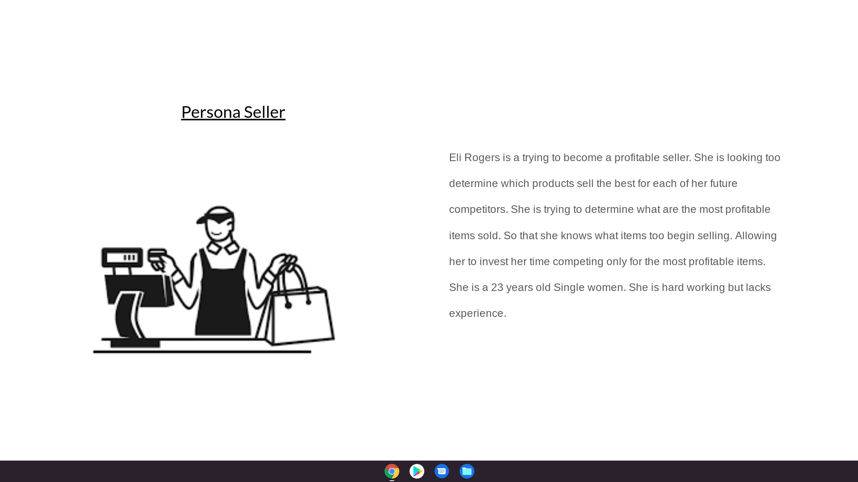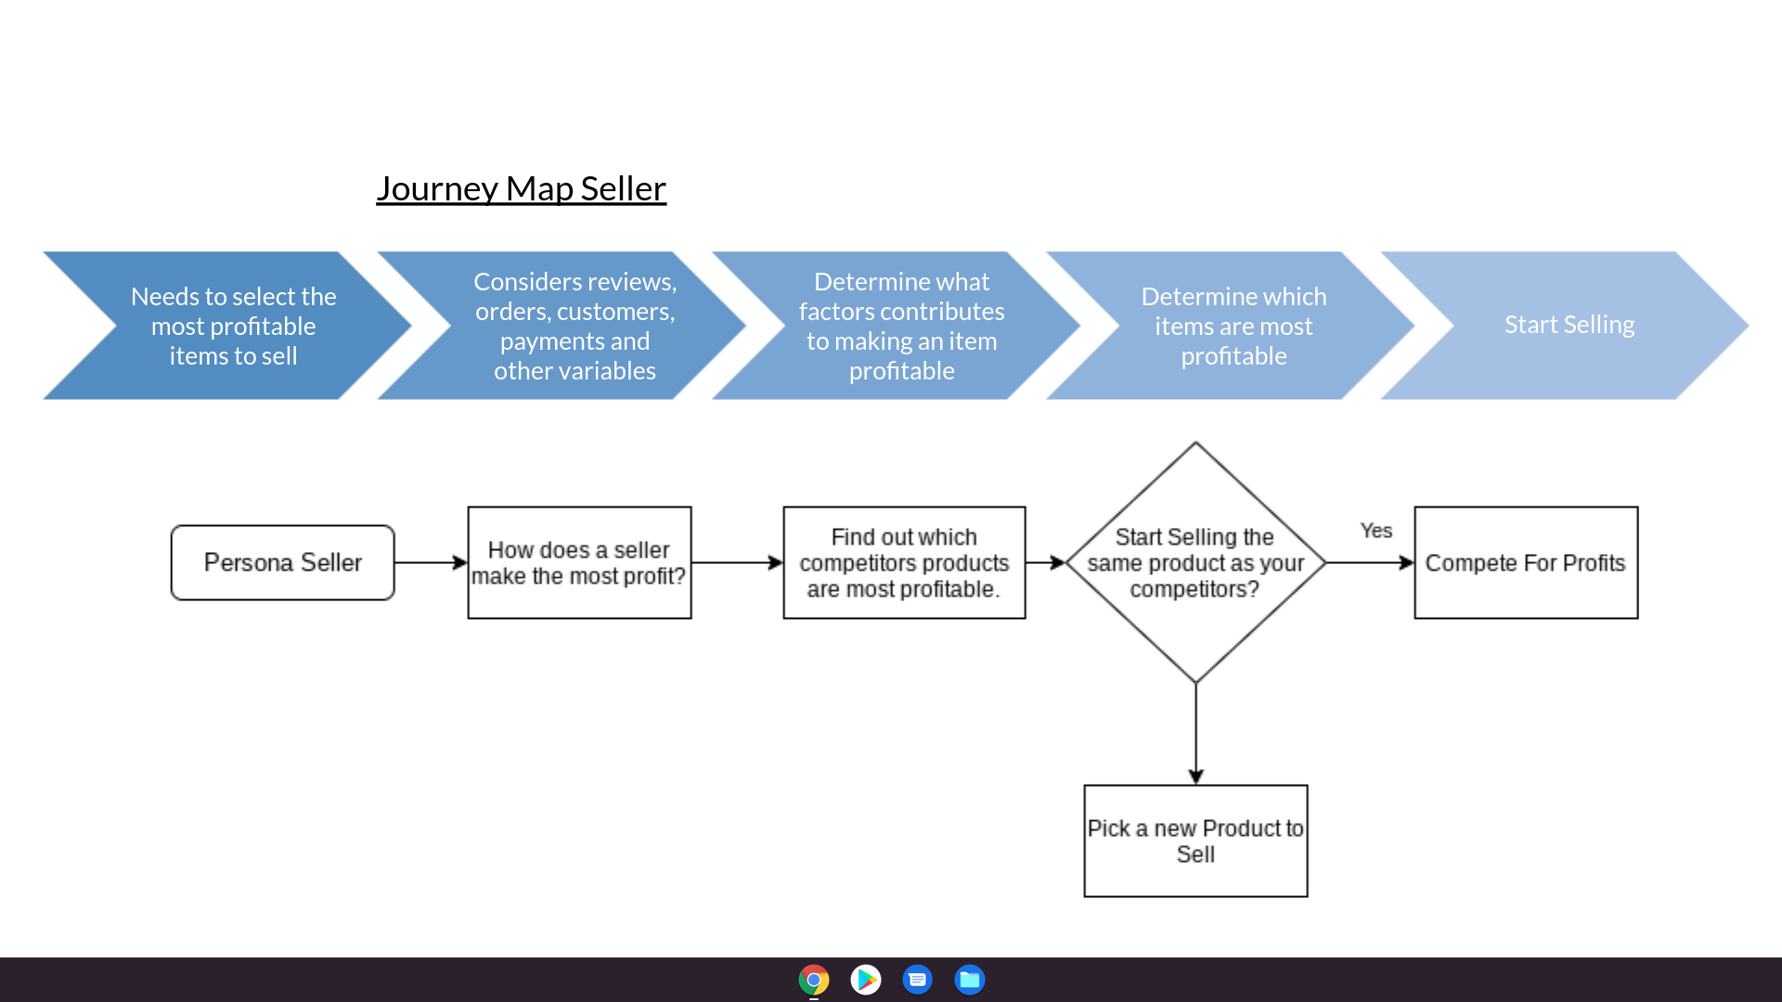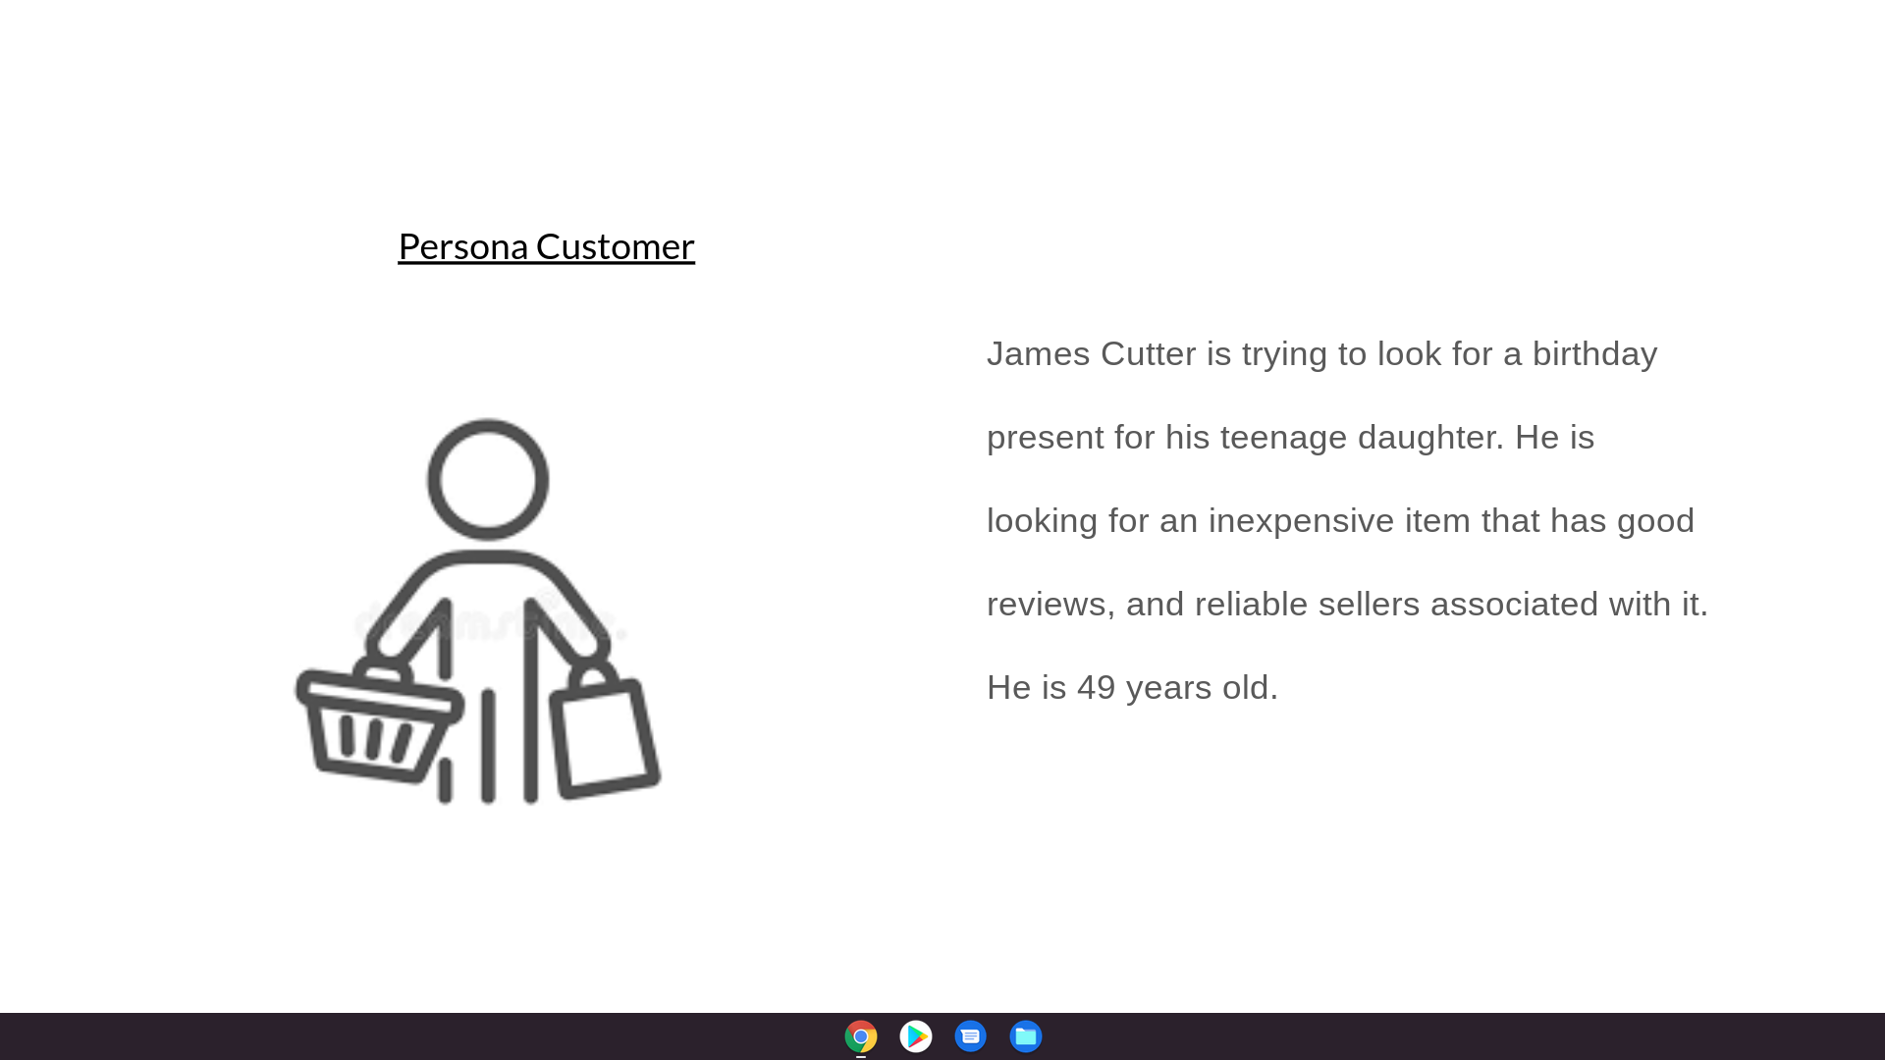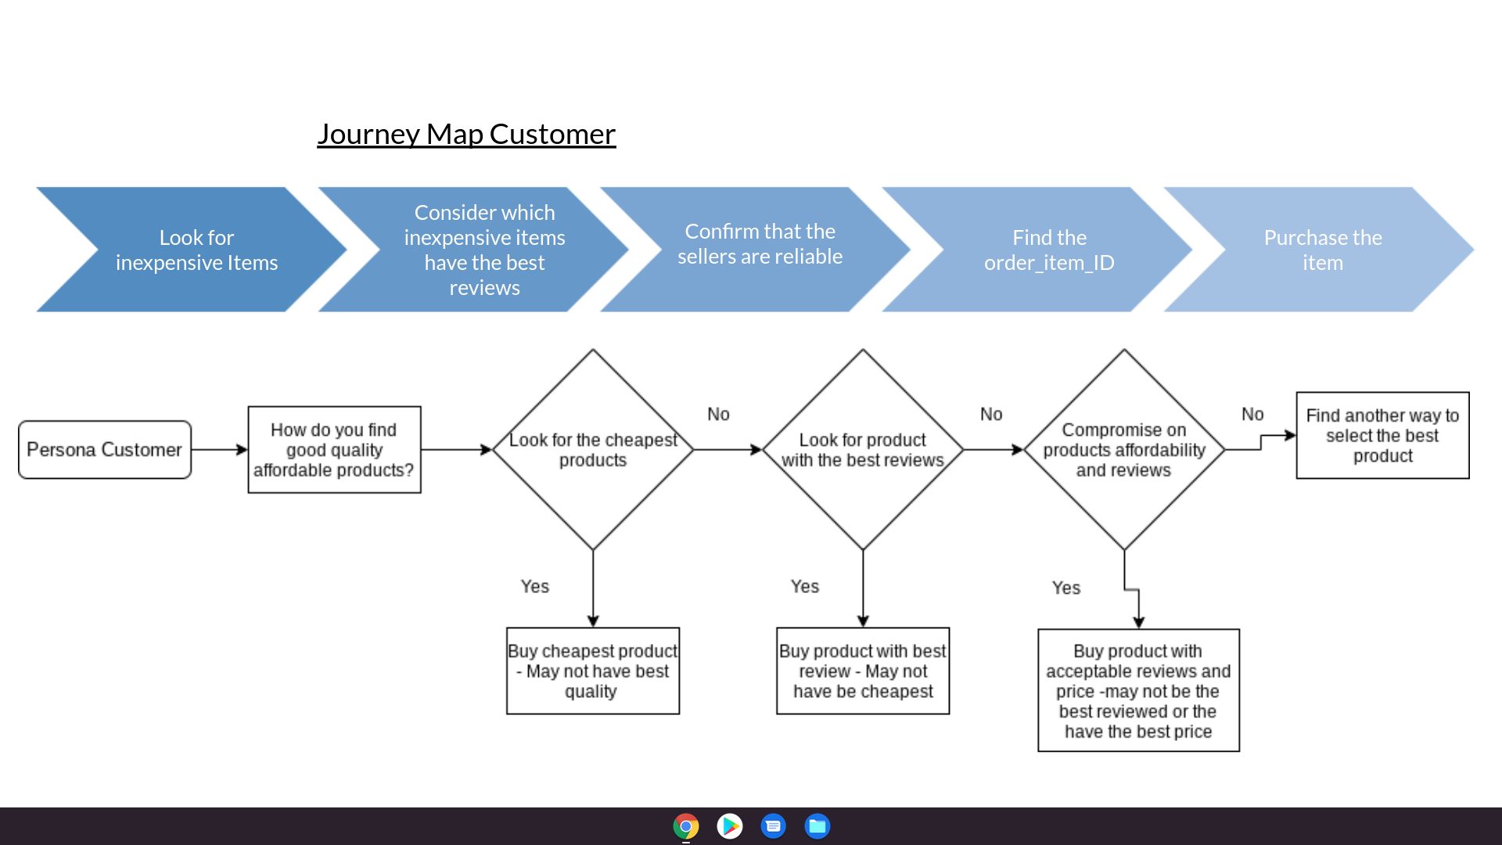

AI Use Case

* Describe predictive analytics use cases involving your data set. Describe in plain English what your model would predict and explain the benefit this would provide, be it a business benefit, a social benefit, or something else.

We have two personas to work with this dataset. One Customer and the other a Seller. This means whatever predictive analytics we do we need for it to effectively be informative for all three of our personas. The best predictive analytics that could be employed may differ for each of these two personas.

For our Seller, we may wish to do some predictions on customer purchases. In this prediction we would be looking at the products sold, the number of products sold, and the overall amount earned by each product. This could potentially be used to inform predictions for future earnings for each product sold by sellers.

For our customers, we want to predict which Sellers offer the best deals. We want low prices. So we could potentially use this data to inform predictions on which sellers will have the best prices in the future. Likewise, we can inform predictions on which seller locations have the best pricing.

These models would allow both our personas to have better access to the information they need to inform their decisions. Customers can find cheaper products, Sellers can predict future purchases, and Investors can determine which sellers will be profitable investments.

* Identify the subset of your data that could be used to train the ML model, and specify your feature columns and label column. **You do not have to create the model**-- that goes beyond the scope of this class.

The data we will be working with for each model type is different. Suffice to say we will need payment_value, Geolocation_state, Customer_unique_id, Seller_id, Order_purcase_timestamp, Product_id, order_id, freight_value. We may need several other columns but these ones would be the main ones used to inform the predictions. The idea would be to use the order_purchase_timestamp to inform sales data, purchases, and Seller profit over time. This way we could use time series analysis to predict future earnings, sales, and purchases.

* Identify five potential ethical issues that could crop up in your use case (every use case has them -- think and you will come up with them) and how you would mitigate or prevent them from causing harm.

The first major issue is that sellers trying to predict what purchases users may make in the future could potentially violate customers' privacy. For example the famous scenario of sending a teenage girl's home and parents information for pregnancy-related products without the parents or even their daughter knowing that she is pregnant.

The second major issue with predicting purchases of customers is that there may be selective stocks purchased or produced by the seller for resale. Non-Vital products that are popular to most customers may be prioritized over products that are essential but are unpopular. There may be ethical issues of sellers trying to keep less of such essential products in stock. For example, an uncommonly used medical product.

Another issue with trying to predict customers' purchases is related to trust. People may be buying things that they don't want to buy. That they don't want to be encouraged to buy. If you make those purchases more accessible it would be counterproductive for them. This may cause a lack of trust. For example, a person who is trying to lose weight may want to cut out sugary sweets. If your model predicts an increase in the amount of sweets bought you might target sales of those items at that customer. This would violate the customers trust.

Another ethical issue is for predicting where to find the lowest cost for customers. Sellers may take advantage of this in an unethical fashion if they have a higher capital reserve than their competitors. They may artificially lower prices and take the financial loss too slowly, driving competitors bankrupt. Then raises prices after their competitors are out of business.

Finally, predicting which sellers have the lowest prices for a product may cause issues with driving newer, and less well-established companies out of business. Newer companies will not have the luxury of charging as little as well-established companies. It may also lead to the bankruptcy of sellers in high rent areas. As they would have to charge more for a product to make up for the higher rents.

References

<https://pitchbook.com/profiles/company/102473-65#overview>

<https://valorcapitalgroup.com/case-studies/olist-redesigned-the-marketplace-business-model-to-fit-the-realities-of-ecommerce-in-brazil/>

<https://www.datanyze.com/companies/ikman/455449763>

<https://play.google.com/store/apps/details?id=lk.ikman&hl=en_US&gl=US&showAllReviews=true>

<https://golden.com/wiki/Udaan_(company)-DB5E534>

<https://udaan.com/about-us>

<https://cedcommerce.com/blog/selling-on-fyndiq-marketplace-bargain-superstore/>

<https://www.investopedia.com/terms/b/balancedscorecard.asp>